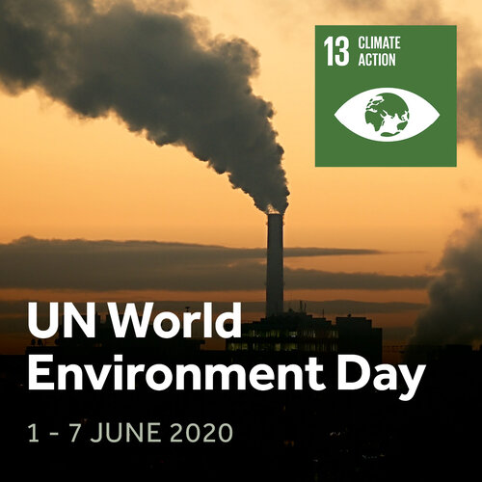
It’s Week 5 of the Great Science Share. This week’s theme is UN Environment Day

Climate action has been so much part of the past year, with inspiration from Greta Thunberg. Be the inspiration for your friends and families by sharing questions about your environment, health and wellbeing.
Share your questions about your local, national and world environment and how we can look after it.
Things children may wonder about…
How clean is the air near to where I live?
How will climate change effect different parts of the world?
What can I do to reduce my impact on the environment or make a positive impact?
Inspirational things to try:
- Learn the difference between climate, weather and what we mean by climate change with this explanation by WWF.
- Wonder Wednesday Live lesson with @DrChips_ on 3rd June 2020 at 10am.
- #AskAQuestion: Connect with Sarah Bridle, Professor of Astrophysics, who describes her journey from stars to food and climate change.
- ﻿Melting polar ice caps make a model of this phenomena.
- ﻿The Big Balloon Blow-Up Work through a simple, hands-on investigation and learn about how scientists are working to save the planet by stopping cows burping!
- How can we clean our dirty water? Featuring Professor Brian Cox. Explore how filtration can be used to clean dirty water in this activity

Visit the website at:
https://www.greatscienceshare.org/getinvolved2020#weekly-themes-2020-wk5
Have fun asking questions and finding out more! We’d love you to share what you do on your class blog too.
Miss Simpson (Science coordinator)
think about it, talk about it and share your questions about it.

