It’s the week of the Great Science Share!

A day to celebrate all of the questions and discoveries you’ve made during this year’s Great Science Share.

To get involved in lots of fun things visit the website at:
https://www.greatscienceshare.org/#great-science-share

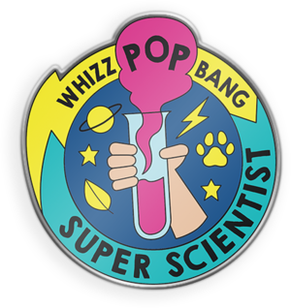

Are you a Super Scientist?

Brand new for 2020 - we’ve partnered with the awesome kids’ science magazine Whizz Pop Bang so that you can commemorate the 2020 Great Science Share!

Receive your FREE enamel Super Scientist pin badge by sharing the science that has fascinated you using this form. (For note: The free badge offer expires on Tuesday 30th June 2020, 4pm and are only available whist stocks last.)
Got some questions? See if they’re answered here in our Super Scientist FAQs or contact us at greatscishare@manchester.ac.uk Share your questions about our oceans and how we can look after them.

There’s also live science lessons
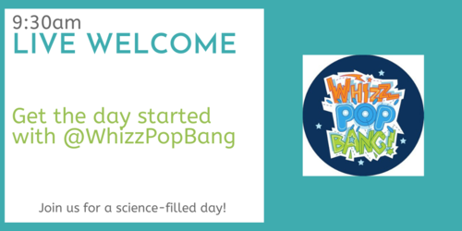
Have fun exploring how science affects our lives!
We’d love you to share what you do on your class blog too.
Miss Simpson (Science coordinator)

think about it, talk about it and share your questions about it.

